**Karachi Institute of Economics and Technology**



**College of Computing and Information Sciences - North Campus**

# Azan Timing Management System

Group Member: Syed Taha Anwer

Course Name and ID: DCN 108149

Abstract:

A network which is applicable to set Azan timing in every states.

I. Problem Statement:

We are making a network which is manage azan timing in every state because we are listen every time Azan on multiple times.

## II. Introduction

Background:

This is a Azan Timing Management System in which we have 6 countries. Each states have a multiple city and multiple areas. We have main hub which will be send a accurate timing to every state and every states. And every state has access to send a timing to every city which can be through by a network

III. Proposed Solution:

A main country network connects with a 4 state and every state and every state connect with multiple cities and all cities connect with a multiple area.

## IV. Objectives and Scope

The main object is that we manage azan timing in every state accordingly by their time periods. Because in every city area’s we listened azan on a different time.

## V. Time frame with contribution (student wise)

I haven’t any partner in my project.

Topology:

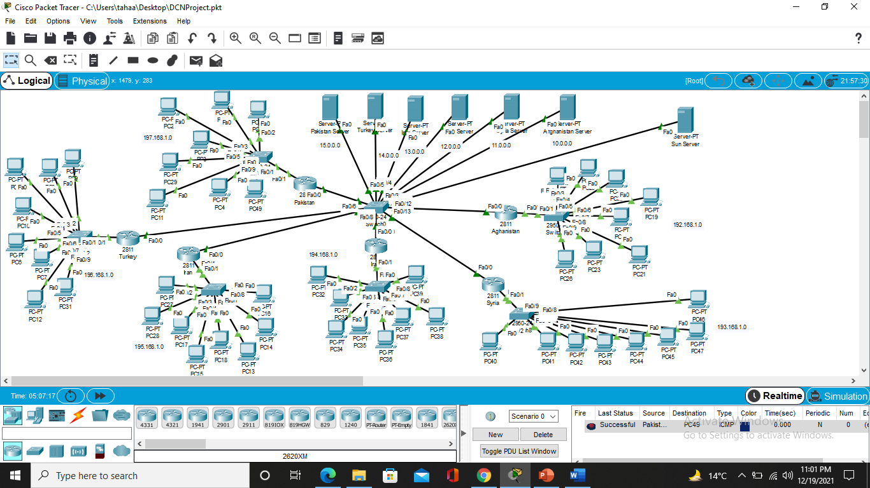

Distribute:

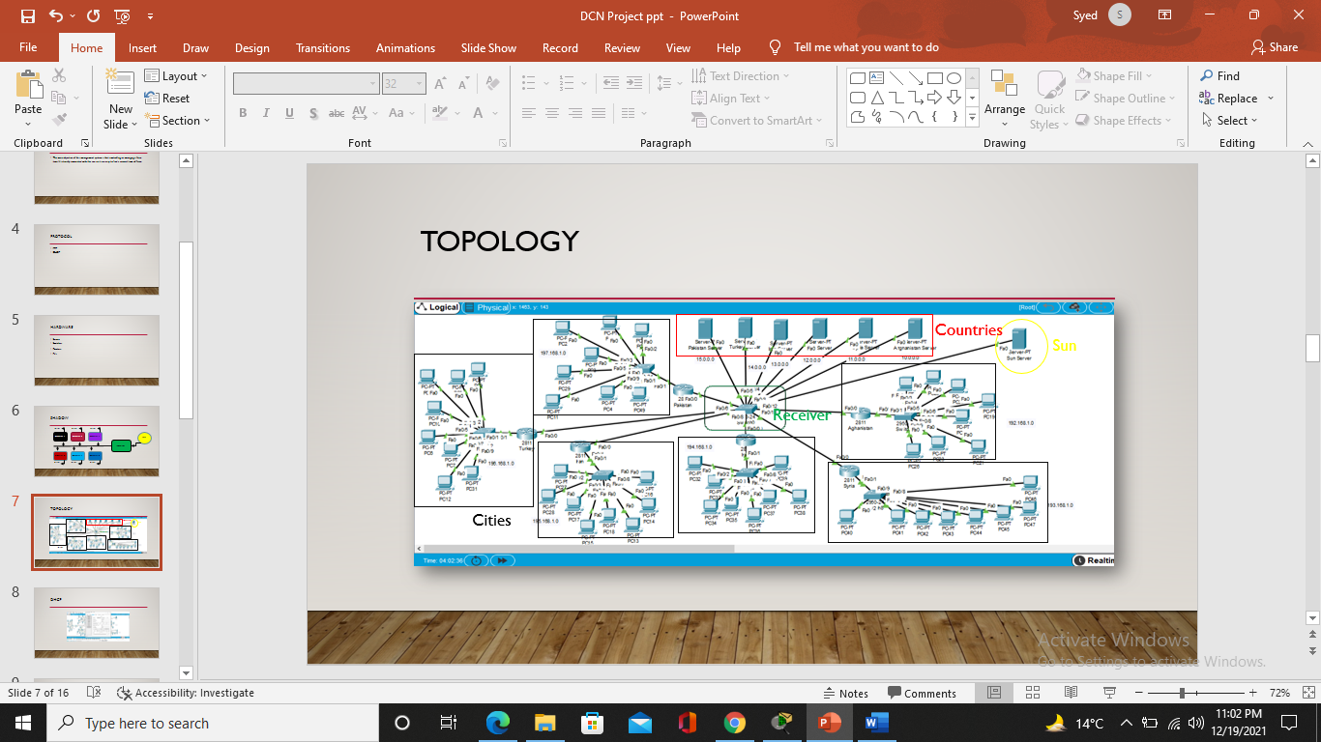

## Conclusion

The main conclusion of this network is to update the existing network and also enhance its capabilities and increase the flexibility of the network which will eventually provide accurate time.

## References

None